Question (4): Find the Voltage across C₁ of figure (1) using Source transformation method (10 marks)
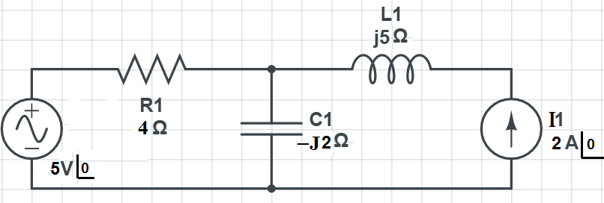 | Figure (1)
Question (5):
From the circuit shown in figure (2), If (V_{o} =$4\underline{{\left|45\right.}^{o}}$) and (ω=10⁶ rad/sec):
- Find the real and imaginary parts of Z1 (6 marks)
- Find the total impedance of the circuit (2 marks)
- Calculate the power factor of the circuit (2 marks)
- Draw the phasor diagram that contains all currents and voltages (5 marks)
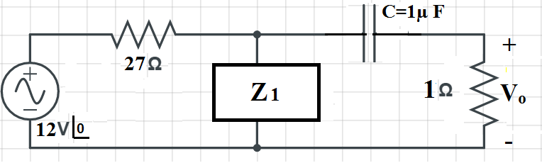 | Figure (2)
Question (6): Find v_{x} in the circuit of figure (3) using the following theorems:
- Nodal Analysis method (6 marks)
- Source transformation method (6 marks)
- Mesh loop method (8 marks)
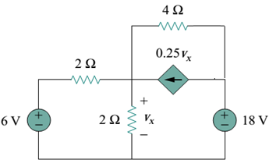 | Figure (3)

